– Building Resilient Infrastructure and Communities (BRIC) –
Applications Open 09/30/22

Federal Fiscal Year (FFY) 2022
- FEMA provides federal funds for the (BRIC) grant program to state, local, tribal, and territorial governments for hazard mitigation activities

- State, territory, and federally recognized tribal set-asides: $2,000,000.00
  - Up to $1,000,000.00 can be utilized for Capability and Capacity-Building.

- Generally, the cost share for this program is 75% federal funding and 25% non-federal funding

BRIC Pre-Application: Please submit as soon as possible (form located on DEM website)
BRIC NOFO BRIC FACT SHEET

– Flood Mitigation Assistance (FMA) –
Applications Open 09/30/22

Federal Fiscal Year (FFY) 2022
- FEMA's FMA grant program provides funds to state, local, tribal, and territorial governments to reduce or eliminate the risk of repetitive flood damage to buildings insured under the National Flood Insurance Program (NFIP).

- Generally, federal cost share funding is up to 75% of the eligible activity costs.

- FEMA may contribute increased federal cost share for properties that are insured under the National Flood Insurance Program and meet definitions of Severe Repetitive Loss or Repetitive Loss.

- FEMA may contribute up to 90% federal cost share (for eligible costs) for activities or projects that impact properties with NFIP insurance that are located within a census tract with a Centers for Disease Control and Prevention (CDC) Social Vulnerability Index (SVI) score of not less than 0.5.
Weekly Workshops through Nevada Division of Emergency Management begin week of October 10.
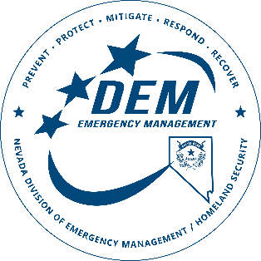
FMA NOFO FMA FACT SHEET
Thank you,
Nevada Division of Emergency Management,
Hazard Mitigation Section
NV Mitigation Grant Resources
CONTACT INFORMATION AND QUESTIONS
Contact Name | Position Title | Phone No. | Email Address
Hazard Mitigation Primary Email | All Hazard Mitigation Staff | - | mitigation@dem.nv.gov
Janell Woodward | State Hazard Mitigation Officer | 775-687-0467 | Janell.woodward@dem.nv.gov
Heather Cinani | Mitigation Operational Management Analyst | 775-687-0466 | hcinani@dem.nv.gov
Ryan Gerchman | Hazard Mitigation Planner | 775-309-9740 | rgerchman@dem.nv.gov

